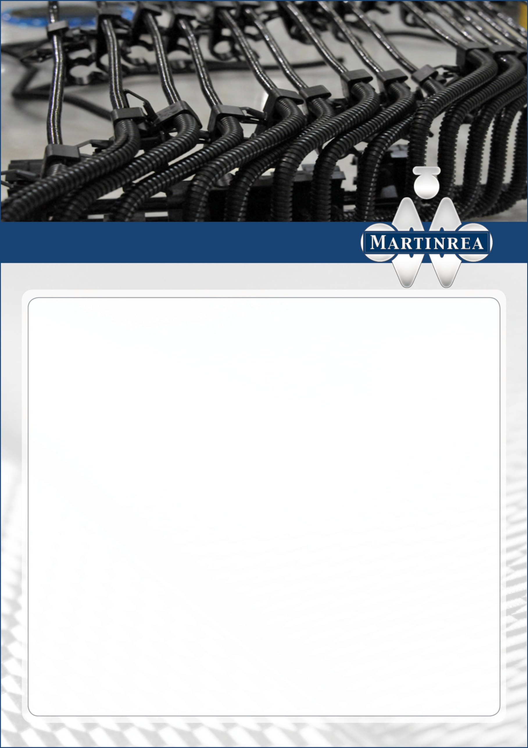

**Tasks:**

* Ensure timely and accurate response to customer requests and ensure commercial offers are in line with company policy and strategy
* Define the commercial strategy for the customers together with the Vice President Sales
* Pilot the completion of the technical and commercial offer liaising with the whole project team
* Lead negotiations with the customer’s purchasing team
* Responsible for price evolution (development, serial life, after-market)
* Responsible for the payment by the customer of tooling, development costs, logistics costs and serial parts at SOP
* Facilitate relationships between plant and customer
* Follow up all customer projects’ profitability (throughout project life and serial life)

**Required qualifications:**

* Bachelor degree (Engineering , Business Management) or equivalent qualification
* Five years or more experience in automotive sales /

program management

* Negotiation skills
* Able to develop customer contacts within the

customer base

* Commercially astute with knowledge of finance to enable quotation completion and subsequent negotiation
* Commercially aware of potential business

opportunities and assess business risk

* Mother tongue or equivalent German
* English language fluent, additional language

(French/Spanish) a plus

* Availability to travel internationally

**Please respond to this ad with your CV if you meet all or most of the requirements above.**

Bill Kreis · HR Manager · bill.kreis@martinrea.com

Fritz-Honsel-Straße 30 · 59872 Meschede

www.martinrea.com

Our Strength is in our People

Martinrea International Inc. is a leader in the development and production of quality metal parts, assemblies and modules, fluid management systems, and complex aluminum products focused primarily on the automotive sector. We employ approximately 15,000 skilled and motivated people at more than 44 manufacturing, engineering and technical centers in Canada, the United States, Mexico, Brazil, Germany, Slovakia, Spain and China. Our business strategy leverages world-class technologies, motivated and talented people, and high-quality products. We aim to be the best automotive parts supplier in the world in the products and services we provide.

One of the divisions, our office in Hofheim am Taunus / Germany called Martinrea Automotive is hiring for a

**Sales Manager Fluid Systems (m/f)**